Lesson 4 Demo 12: Create configmap from an Env File

This section will guide you to:

* Create a configmap from an env file

This lab has one sub-section, namely:

1. Creating a configmap from an env file

**Note:** If you don’t have an existing Kubernetes cluster, refer to the Demo 1.1 of Lesson 1.

**Step 1:** Creating a configmap from an env file

* Start the kubernetes cluster in the lab
* Create a directory at *configure-pod-container/configmap/* as shown below:

*sudo mkdir -p configure-pod-container/configmap*

* Download the env file from the following link of the Kubernetes sample data using command as shown below:  
    
  *sudo wget* [*https://kubernetes.io/examples/configmap/game-env-file.properties -O configure-pod-container/configmap/game-env-file.properties*](https://kubernetes.io/examples/configmap/game-env-file.properties%20-O%20configure-pod-container/configmap/game-env-file.properties)

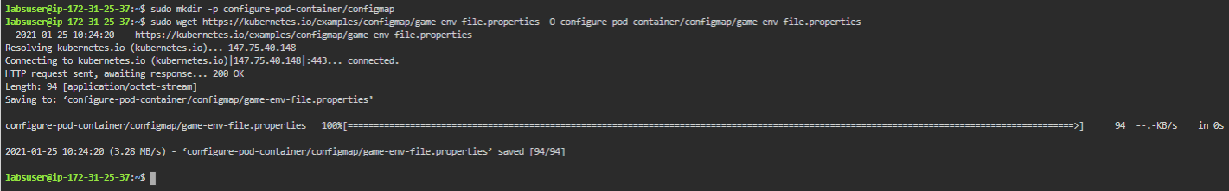

* The sample env file looks like the one shown below:  
    
  *cat configure-pod-container/configmap/game-env-file.properties*

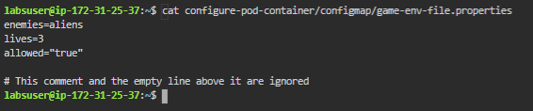

* We will now use *--from-env-file* to create a configmap from an env-file as mentioned above  
    
  *kubectl create configmap game-config-env-file *

*--from-env-file=configure-pod-container/configmap/game-env-file.properties*

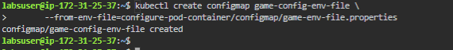

* You can verify the created configmap using **kubectl get** command, the output of which will look as shown below:  
    
  *kubectl get configmap game-config-env-file -o yaml*

